Assignment #3 – Business 100
Name:

Background information needed to answer Question #1:

Below are three different basketballs that each have unique features. Review those features and also the customer profile of your customers to determine which basketball you think will sell the most.

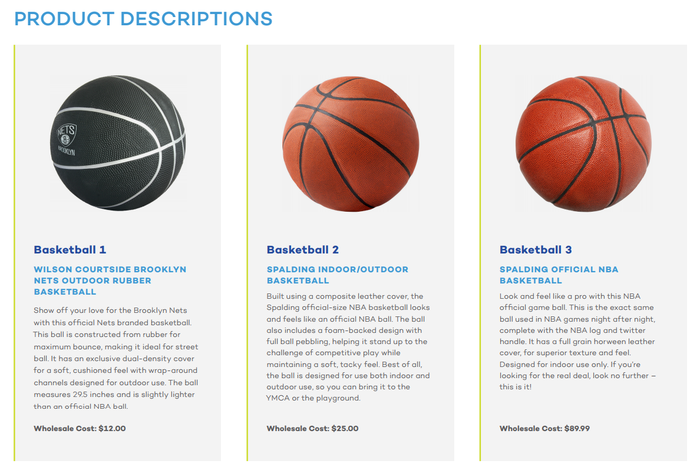

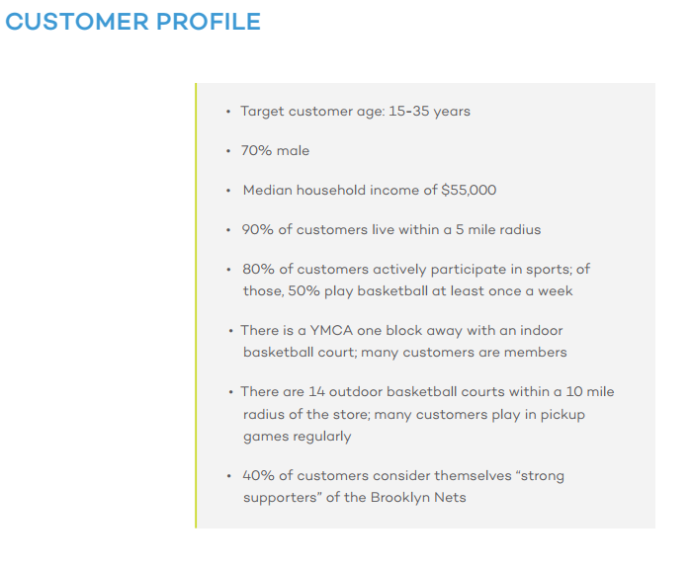
Question 1:
Based on the information provided in the customer profile, which basketball will sell the most?

- Basketball 1
- Basketball 2
- Basketball 3

What information from the customer profile indicates that your basketball choice will sell the most?
Basketball 2 will sell the most because the ball can be played either outdoor or outdoor. Moreover, there are both outdoor and indoor pitches in the vicinity. Most of the target customers are members of a YMCA which has an indoor court. The vicinity has 14 outdoor basketball courts and most people are located within 5 mile radius from the pitches, thus a need for a ball that can be used for both indoor and outdoor aspects. Another reason that basketball two will sell the most is because it is cost friendly. Comparing the price of basketball 2 to the household income, then the price can be argued to be fair. Ball 2 has most characteristics that favor the target audience and therefore, it will sell the most.
Background information needed to answer Question #2:

Review the survey results below that asked potential buyers about where they are most likely to purchase these products.

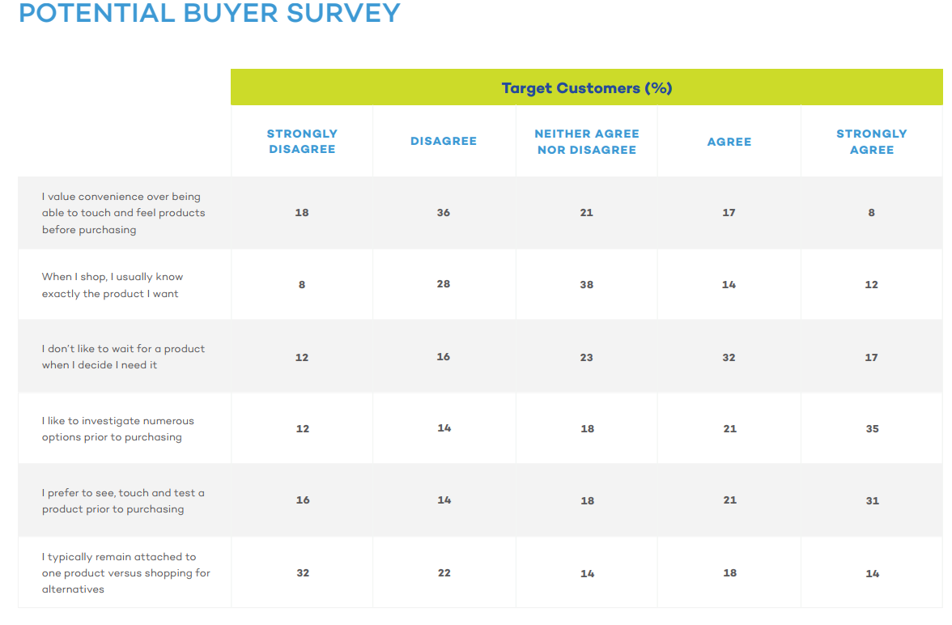
Question #2:

Where are potential buyers most likely to purchase a basketball?
- Traditional Store
- Online

Explain your answer using the survey data above:
In my opinion, most potential buyers will likely purchase the ball at the traditional store. In the potential buyer review sheet, the potential buyers want control of what they need. Most customers prefers touching and seeing the product before they purchasing it. Therefore, most of the buyers will be compelled to visit the traditional stores and choose the ball of their choice. In review of the data in the survey sheet, it is apparent most of the potential buyers will opt on first seeing the ball before buying and thus the traditional store will be the ideal place for most buyers.
Background information needed to answer Question #3:

Below are three recommended advertisements, including a special deal promotion, for the basketball that is expected to sell the best. Review and based on what you know about the customer profile that shops at this store location, determine which promotional activity will sell the most product at this particular store.

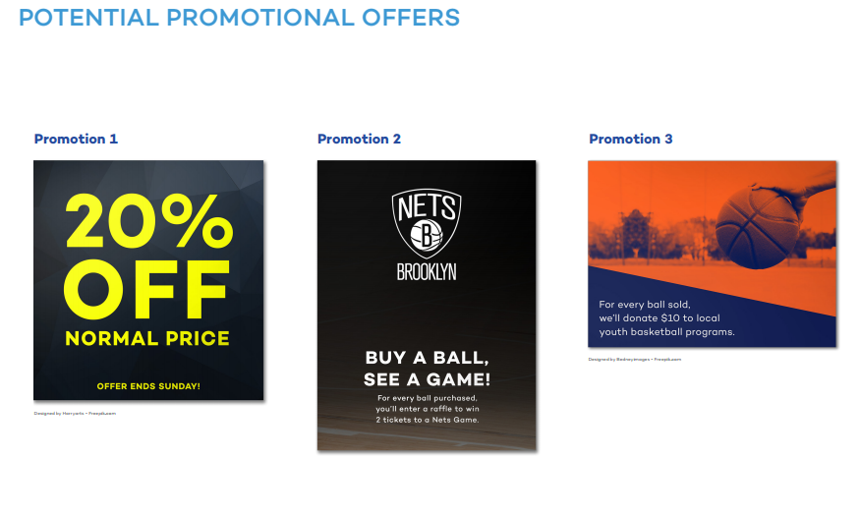
Question #3:

Which promotional activity will sell the most products?

- Promotion 1
- Promotion 2
- Promotion 3

Explain your rationale for your decision and include data from the customer profile:
In my opinion, promotion activity 2 will sell most basketballs. In regard to the customer profile, 40% of the potential buyers are Brooklyn nets fans and therefore will not afford to miss the chance to attend the game for free. Additionally, 80% of the potential buyers are active participators of basketball and high likely they would want to attend a live game. Therefore, promotion activity gives potential buyers an option to attend and watch their favorite team in action.
Background information needed to answer Question #4:

Review the pricing options available for each of the three products below. Also review the wholesale cost to purchase the product as you review the best pricing strategy for all three products.
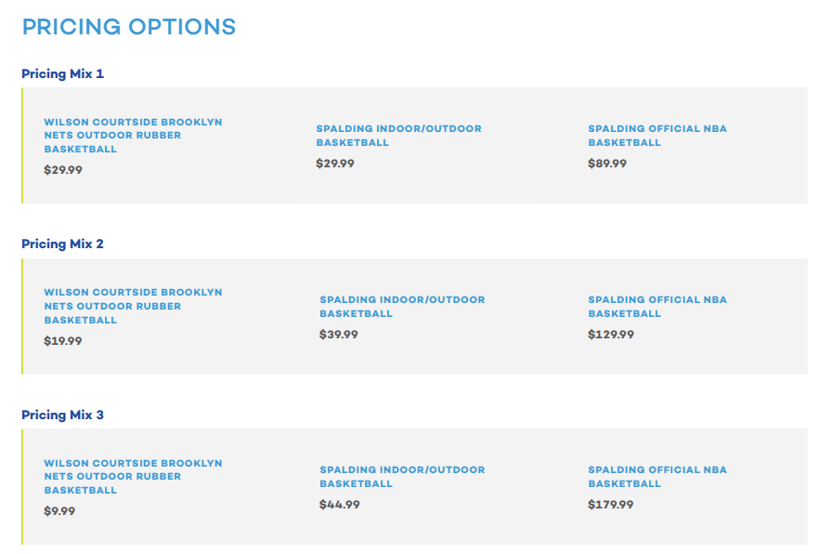
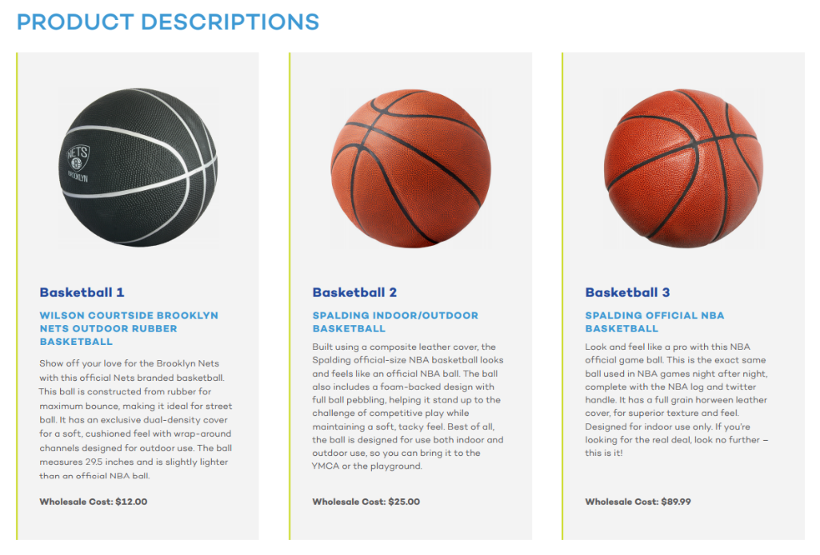
Question #4:

Based on your knowledge of Pricing Strategies, choose the Pricing Mix Option thathas the best pricing mix for all three products.

- Pricing Mix 1
- Pricing Mix 2
- Pricing Mix 3

Please explain which Pricing Mix you selected and why?
According to my knowledge on pricing strategies, pricing mix 2 has the best mix for the three basketballs. Any price below the perceived price of the basketball will lower the potential revenue of the company as well as the customers suspecting the quality of the basketball. On the other hand, overpricing the basketball can scare away potential buyers. Therefore, when pricing of the basketball, it is crucial to consider the potential customers as well as the market variables. In my opinion, pricing mix 2 is fair for both the buyer and the seller. It is the best since it is a win-win situation for both the seller and the potential buyer. Right pricing invites many customers, and therefore, increases revenue for the company.

Background information needed to answer Question #5:

The company that makes one of the basketballs is looking to rebrand the product. They have asked for your input on possible brands ideas. First, read the Brand Vision statement which summarizes the goal for the new brand. Then, look at the logo, name, and tagline recommendations.
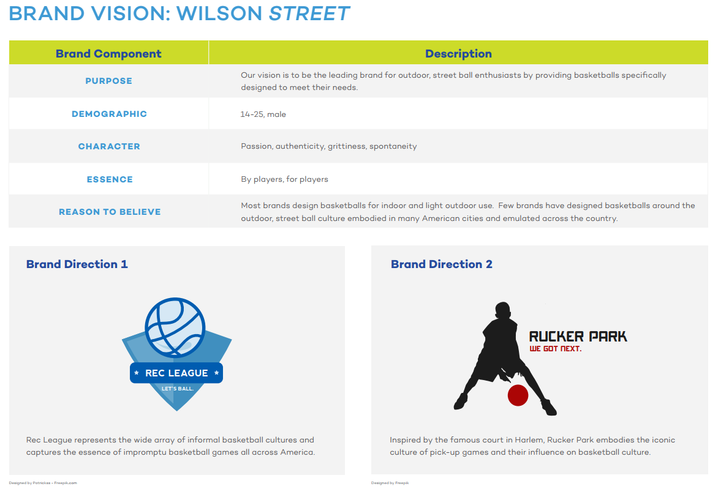
Question #5:

Which of the Brand Directions best meets the goals of the brand vision?
- Brand Direction 1
- Brand Direction 2

Why do you think your selected Brand Direction meets the goals the best?
According to me, brand direction 2 meets the goals the best because the brand portrays the perception of basketball. The brand reflects the core culture of the company. When branding, creating the impression on the logo as well as the words potential clients will use is crucial to the success of the company. The brand direction 2 creates an impression which meets the goals.

Background information needed to answer Question #6:

A great sales pitch has 5 components: introduction, problem, solution, objections, call to action. Review the 5 components of a successful sales pitch as well as a few example sales pitches below.
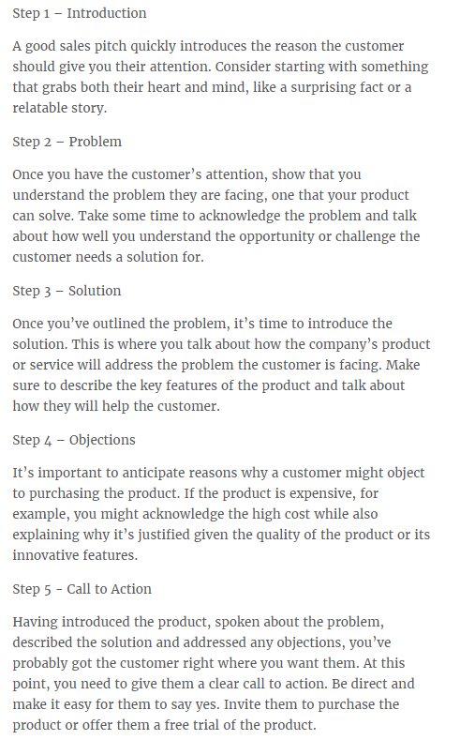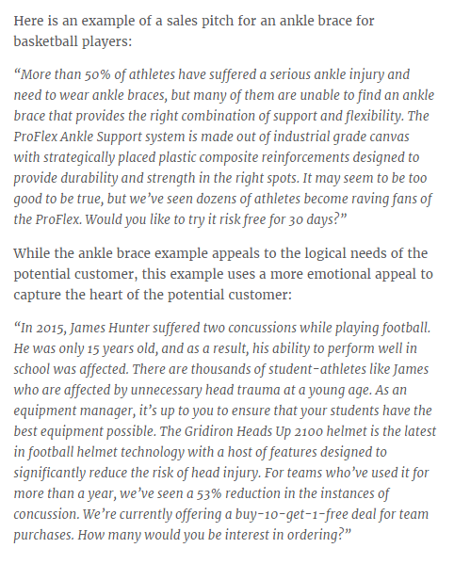
Question #6:

Write a sales pitch that you would use to try and convince someone to purchase this product.
As all type of sports create a good shape to humans, basketball works all muscles in your arms, legs and lower and upper body. In addition, it keeps people healthy and keeps the mind more focused. Many people, however, cannot access outdoor pitches due to working hours. Therefore, we provide out indoor and outdoor quality basketballs at a friendly price. Would you like to try the best quality?

Next step: submit your work
- Save this document to your desktop
  - Navigation: select file at the top, save as – select desktop, and select save
- Log into your class and select Assignment #3 on the left, scroll down and select “submit your work”, click browser my computer, find your file on the desktop, click open, then click submit.
- If you have any issues email me or call me.
I will provide you assignment feedback and you can then make any changes you would like and resubmit for grading.
Congrats on completing assignment #3!

